CS365 Operating System
Midterm Exam

Tyler Bartlett
Name: _________________________

Question Number | Score
1
2
3
4
5
Total:

Question1:
Explain the following terminology: (1pt each)

- System Call
System calls provide an interface to the services provided by the operating system and there are roughly 6 major types; process controll, file manipulation, device maniulation, information maintenance, communications, and protection.

- Process
A process is a program in exection. It is the unit of work in a time sharing system consisting of a collection of many processes, both user generated to execute user code and those generated by the operating system executing system code.

- I/O-bound process
An I/O-bound process is one that spends more of its time doing I/O than it spends doing computations.

- Context Switch
The Operating System saves the user stack pointer of the process currently being executed and transfers control to the kernel clock interrupt handler which then saves the states of the registers of the process. The Operating System calls the scheduler to determine the next process to execute then retrieves state from the Process Control Block and restores its registers to the state before the interrupt.

- LWP

- Symmetric multiprocessing
each processor performs all tasks within the operating system. SMP means that all processors are peers; no boss–worker relationship exists between processors. Notice that each processor has its own set of registers, as well as a private—or local —cache. However, all processors share physical memory.

Question2:

2.1 Explain and describe 3 different types of process schedulers. (3 pts)

Three types of process schedulers are long term, midterm, and short term. The long term scheduler chooses which programs are sent to the system to be processed and uses a queue to load them into memory for execution. The midterm scheduler controls proces swapping by taking the processes out of memory. The short term scheduler changes the ready state of processes to running and allocates the CPU to the processes.

2.2 Describe 3 different multithreading models for mapping user threads to kernel threads. Also, describe at least one advantage or disadvantage for each model. (5 pts)
Many-to-One multithreading: Maps many user-level threads to one kernel thread. Thread management is done by thread library in user space, so it is efficient. The entire process will block if thread makes blocking system call. Because only one thread can access kernel at a time, multiple threads unable to run in parallel on multicore systems.

One-to-One multithreading: Maps each user thread to a kernel thread. Provides more concurrency than many-to-one model by allowing another thread to run when a thread makes a blocking system call. Also allows multiple threads to run in parallel on multiprocessors. Only drawback is that creating a user thread requires creating the corresponding kernel thread. Because the overhead of creating kernel threads can burden performance of an application, most implementations of this model restrict number of threads supported by the system.

Many-to-Many multithreading: Multiplexes many user-level threads to a smaller or equal number of kernel threads. Number of kernel threads may be specific to either a particular application or a particular machine (an application may be allocated more kernel threads on a multiprocessor than on a single processor).

2.3 Draw the state diagram of a process from its creation to termination, including all transitions, and briefly elaborate every state and every transition . (5 pts)
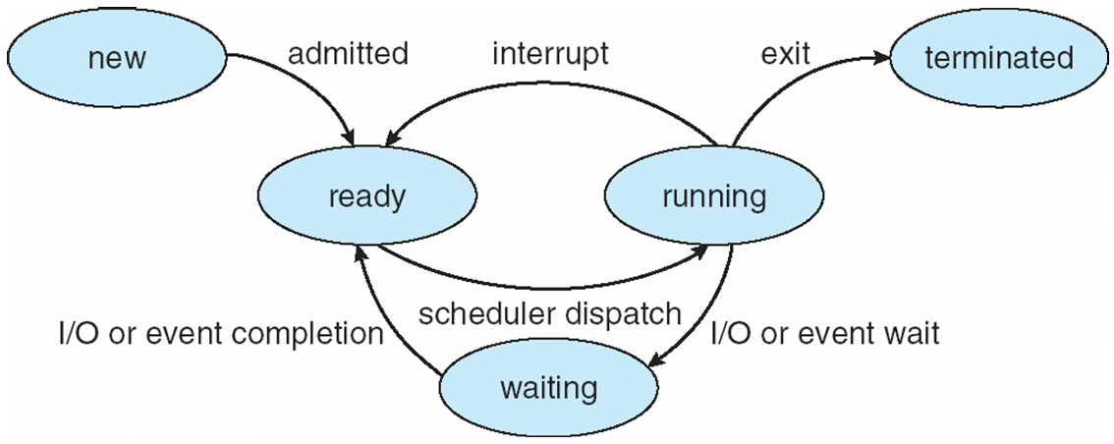

New: The process is being created.
Running: Instructions are being executed.
Waiting: Process is waiting for some event to occur (such as an I/O completion or reception of a signal).
Ready: The process is waiting to be assigned to a processor.
Terminated: The process has finished execution.

Question3:
According to the bounded buffer code below in shared memory system, draw the ring structure with size 4 and indicate the location of “in” and “out” for each time space. (If the buffer is full or empty, indicates how many jobs are waiting) (10pts, 0.5 pt for each)

Producer View
while (true) {
/* produce an item and put in next Produced*/
while (count == BUFFER_SIZE)
; // do nothing

buffer [in] = nextProduced;
in = (in + 1) % BUFFER_SIZE;
count++;
}

Consumer View
while (true) {
while (count == 0)
; // do nothing

nextConsumed= buffer[out];
out = (out + 1) % BUFFER_SIZE;
count--;
/* consume the item in next Consumed
}

Time Action in:0 out:0 count:0 waiting:0
1 Producer produces 2 jobs in = 2 out = 2 count = 2 waiting = 0

2 Consumer consumes 1 job in = 1 out = 1 count = 1 waiting = 0

3 Producer produces 3 jobs in = 0 out = 0 count = 4 waiting = 0

4 Consumer consumes 3 jobs in = 1 out = 1 count = 1 waiting = 0

5 Consumer consumes 3 jobs in = 0 out = 0 count = 0 waiting = 2

Question4:

By “Multilevel Queue Fixed priority” scheduling algorithm, draw the CPU scheduling Gantt chart (5 pts) and complete the table for the given processes information. ( 10 pts)

Process Burst time Arriving time Algorithm

- 1st Foreground P1 50 0.0 RR interval:20
P2 15 30.0 (RR is a non-preemptive
P3 45 30.0 algorithm)

- 2nd Foreground P4 40 0.0 SJF Preemptive
P5 10 120.0

- Background P6 30 60.0 FCFS
P7 20 130.0

Gantt Chart:

Scheduling criteria:

 | P1 | P2 | P3 | P4 | P5 | P6 | P7
Waiting time
Turnaround time
Response time

Question5:

Circle the best answer. (25 pts, 1 pt for each)

1. The major difficulty in designing a layered operating system approach is ____.
A) appropriately defining the various layers
B) making sure that each layer hides certain data structures, hardware, and operations from higher-level layers
C) debugging a particular layer
D) making sure each layer is easily converted to modules

2. A boot block ____.
A) typically only knows the location and length of the rest of the bootstrap program
B) typically is sophisticated enough to load the operating system and begin its execution
C) is composed of multiple disk blocks
D) is composed of multiple disk cylinders

3. Microkernels use _____ for communication.
A) message passing
B) shared memory
C) system calls
D) virtualization

4. The UNIX fork() system call creates a new process. What is the equivalent system call in WINDOWS:
A) NTCreateProcess()
B) process()
C) CreateProcess ()
D) getpid()

5. All access to POSIX shared memory requires a system call.
A) True
B) False

6. When a child process is created, which of the following is a possibility in terms of the execution or address space of the child process?
A) The child process runs concurrently with the parent.
B) The child process has a new program loaded into it.
C) The child is a duplicate of the parent.
D) All of the above

7. Cancellation points are associated with ____ cancellation.
A) asynchronous
B) deferred
C) synchronous
D) immediate

8. The _____ model allows a user-level thread to be bound to one kernel thread.
A) many-to-many
B) two-level
C) one-to-one
D) many-to-one

9. Which of the following is true of cooperative scheduling?
A) It requires a timer.
B) A process keeps the CPU until it releases the CPU either by terminating or by switching to the waiting state.
C) It incurs a cost associated with access to shared data.
D) A process switches from the running state to the ready state when an interrupt occurs.

10. ____ is the number of processes that are completed per time unit.
A) CPU utilization
B) Response time
C) Turnaround time
D) Throughput

11. ____ scheduling is approximated by predicting the next CPU burst with an exponential average of the measured lengths of previous CPU bursts.
A) Multilevel queue
B) RR
C) FCFS
D) SJF
12. The ____ scheduling algorithm is designed especially for time-sharing systems.
A) SJF
B) FCFS
C) RR

13. Which of the following scheduling algorithms must be nonpreemptive?
A) SJF
B) RR
C) FCFS
D) priority algorithms

14. Which of the following is true of multilevel queue scheduling?
A) Processes can move between queues.
B) Each queue has its own scheduling algorithm.
C) A queue cannot have absolute priority over lower-priority queues.
D) It is the most general CPU-scheduling algorithm.

15. A message-passing model is ____.
A) easier to implement than a shared memory model for intercomputer communication
B) faster than the shared memory model
C) a network protocol, and does not apply to operating systems
D) only useful for small simple operating systems

16. _____ provide(s) an interface to the services provided by an operating system.
A) Shared memory
B) System calls
C) Simulators
D) Communication

17. The list of processes waiting for a particular I/O device is called a(n) ____.
A) standby queue
B) device queue
C) ready queue
D) interrupt queue

18. The _____________ refers to the number of processes in memory.
A) process count
B) long-term scheduler
C) degree of multiprogramming
D) CPU scheduler

19. Many operating system merge I/O devices and files into a combined file because of the similarity of system calls for each.
A) True
B) False

20. A _________________ saves the state of the currently running process and restores the state of the next process to run.
A) save-and-restore
B) state switch
C) context switch
D) none of the above

21. A ____ provides an API for creating and managing threads.
A) set of system calls
B) multicore system
C) thread library
D) multithreading model

22. The most common technique for writing multithreaded Java programs is _____.
A) extending the Thread class and overriding the run() method
B) implementing the Runnable interface and defining its run() method
C) designing your own Thread class
D) using the CreateThread() function

23. Which of the following statements regarding threads is false?
A) Sharing is automatically provided in Java threads.
B) Both Pthreads and Win32 threads share global data.
C) The start() method actually creates a thread in the Java virtual machine.
D) The Java method join() provides similar functionality as the WaitForSingleObject in Win32.

24. A _____ uses an existing thread — rather than creating a new one — to complete a task.
A) lightweight process
B) thread pool
C) scheduler activation
D) asynchronous procedure call

25. A thread is composed of a thread ID, program counter, register set, and heap.
A) True
B) False

